Backend Setup Instructions:

1. Need to install Postgres- PgAdmin for Database Setup
2. Download POSTGRESQL version 15
3. Graphical user interface

   Description automatically generated with medium confidence

Link to install : <https://www.enterprisedb.com/downloads/postgres-postgresql-downloads>

Select on windows/mac option and the installation will start

1. Once Postgres has been installed, open the PgAdmin4 Application. You will be asked to enter a password

** **Make sure you set the password as 12345 for the database** **

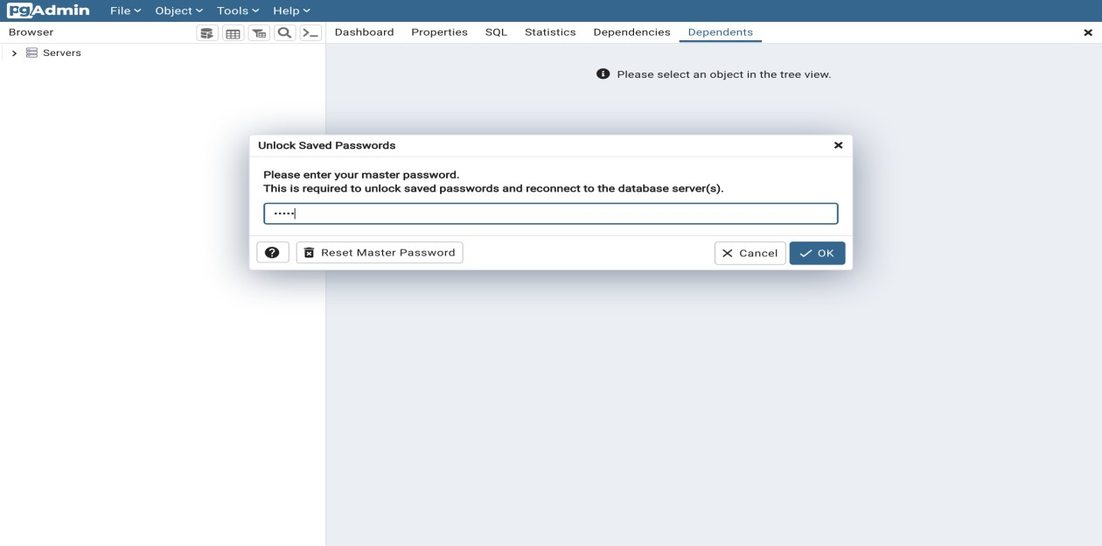

1. Once the installation is complete and password has been setup, check your preferences for binary path to Postgres. If the binary path is empty enter

**C:\Program Files\PostgreSQL\15\bin**

**If your PostgreSQL installation resides in C drive**

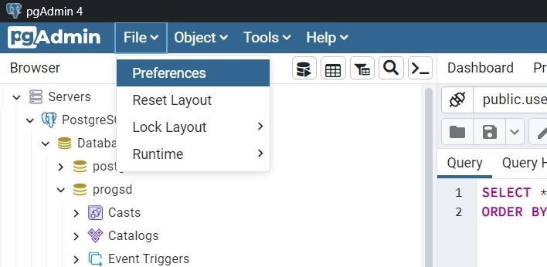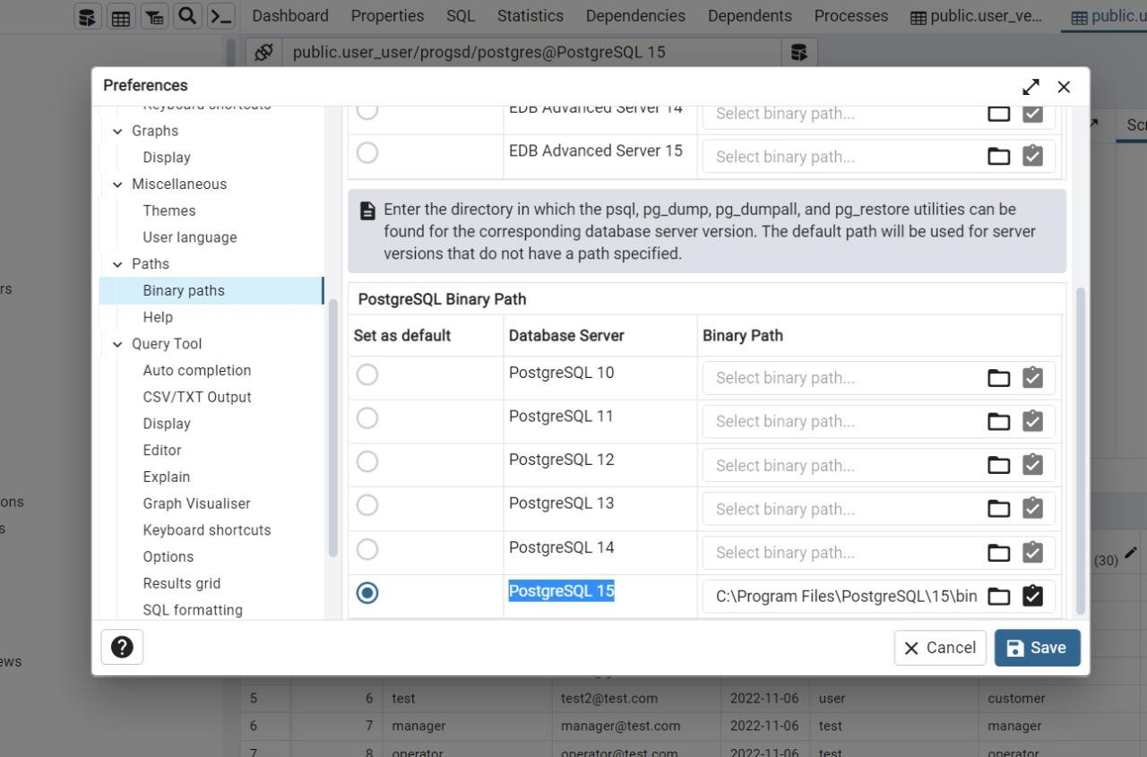

1. Once Pg Admin has been installed, open the Server Tab on the left side, Once you are in the Database Section, you will find a postgres default database, create a database called **progsd**

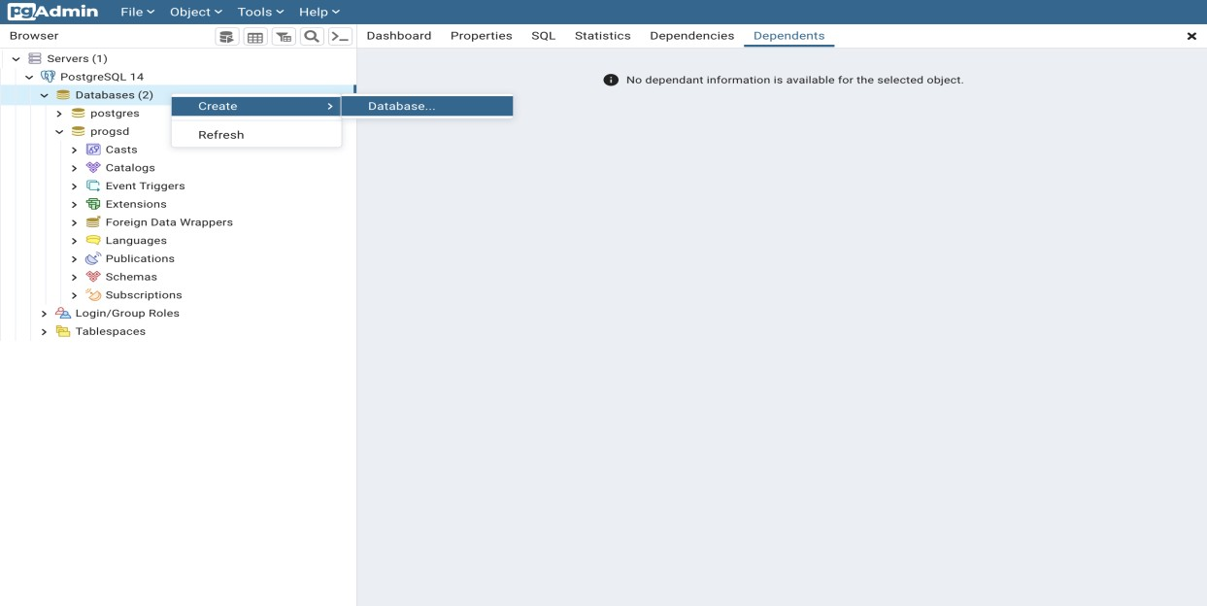

1. After the progsd Database has been created, go into the directory (Backend) where the requirements.txt is present and use:

**pip install -r requirements.txt**

1. Once the requirements have been installed

Use command: **python manage.py migrate**

This will migrate all the databases to the created table progsd

You would see a screen something like the below figure.

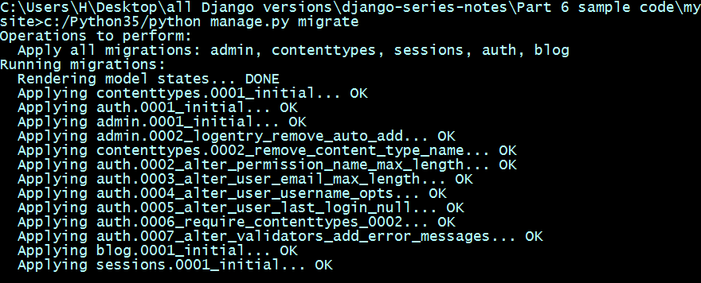

1. After migrations are completed

Use command : **python manage.py runserver**

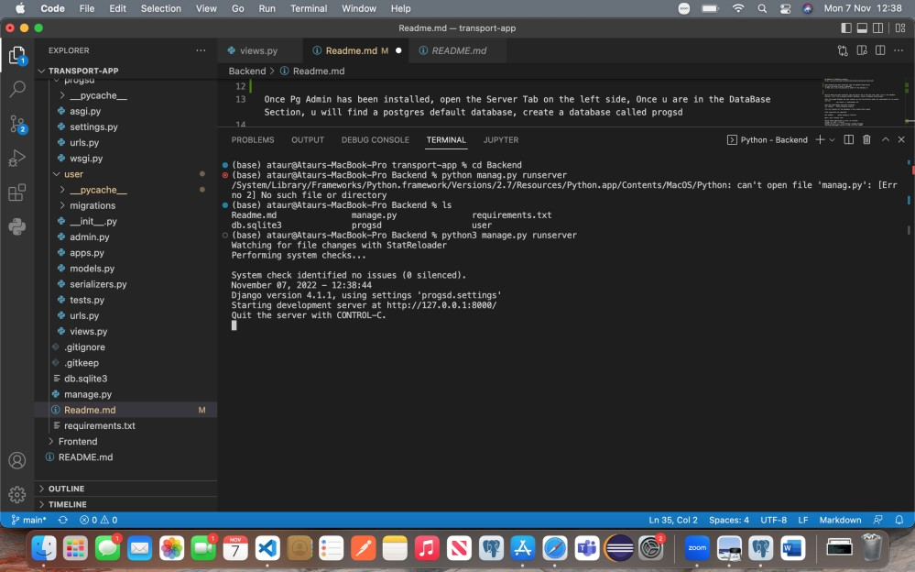

You will get a screen like this.

Your backend server is up and running.